Useradd [option] name

Groupadd rd

Useradd -g rd eric

Id eric

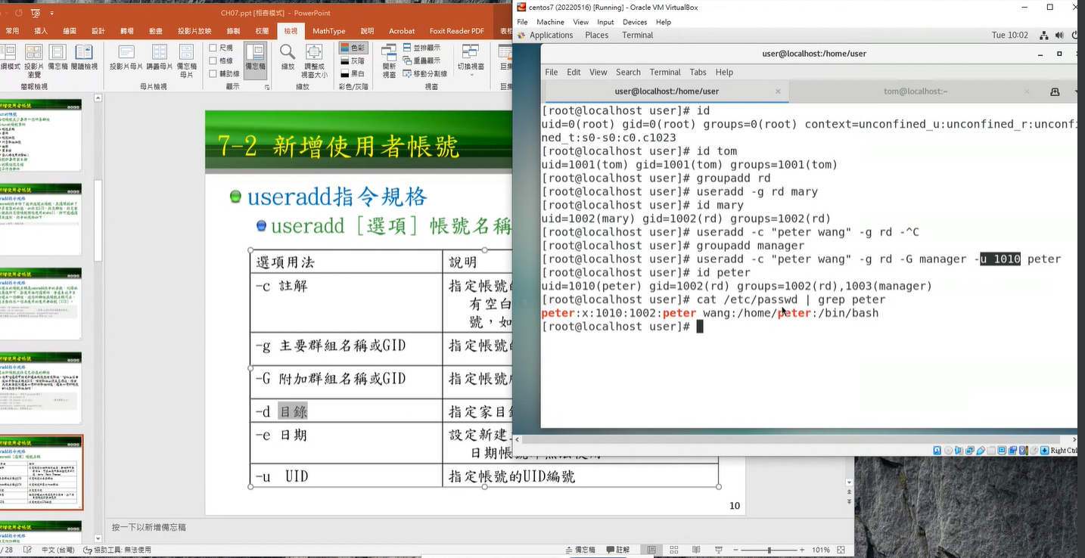

Ls -l -d test

/to see all the permission for the directory “test” must add ‘-d’

/if not use:

Ls -l test

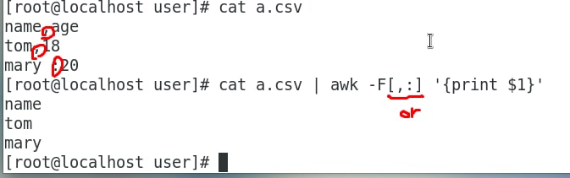

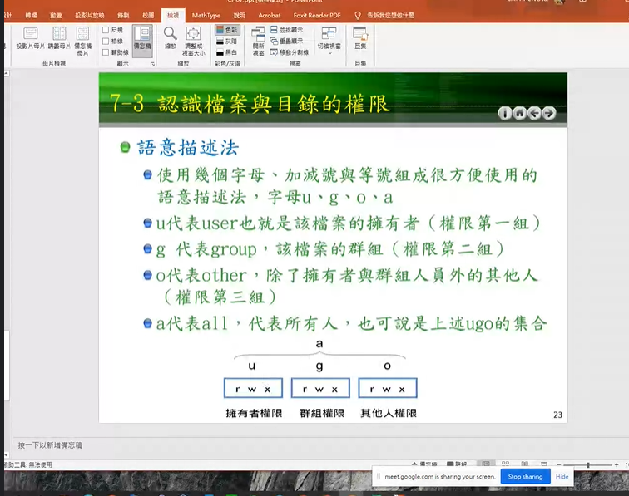

The Permission Groups used are:

* **u** – Owner
* **g** – Group
* **o** – Others
* **a** – All users

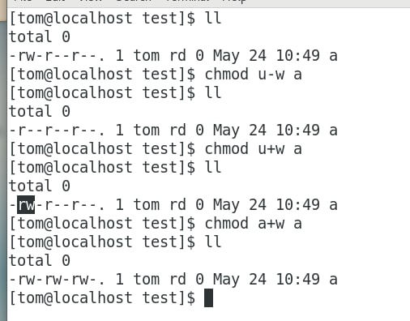

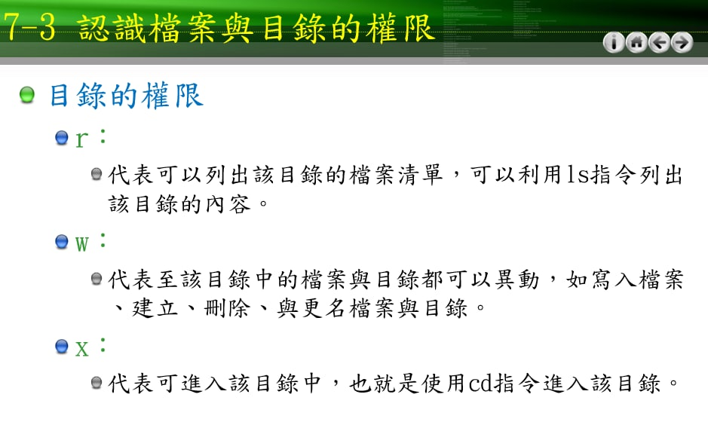

The Permission Types that are used are:

* **r** – Read
* **w** – Write
* **x** – Execute

Mkdir dir1

<https://kknews.cc/zh-tw/code/3vpeby3.html>

<https://snapcraft.io/install/john-the-ripper/centos>